Data Sheet
Product Information
Product Name | : | Recombinant Mouse Interleukin-4 (rmIL-4)
Synonyms | : | B-cell stimulatory factor 1 (BSF-1)
Description | : | Recombinant mouse Interleukin-4 produced in E. coli is a non-glycosylated 13.5 kDa protein containing 121 amino acids. IL-4 induces the expression of class II major histocompatibility complex and Fc receptors on B-cells and monocytes. It also acts on T-lymphocytes, mast cell lines and several other haematopoietic lineage cells including granulocyte, megakaryocyte and erythroid precursors as well as macrophages.
NCBI Accession No. | : | NM_021283.2
Amino acid sequence | : | MHIHGCDKNHLREIIGILNEVTGEGTPCTEMDVPNVLTATKNTTESELVCRASKVLRIFYLKHGKTPCLKKNSSVLMELQRLFRAFRCLDSSISCTMNESKSTSLKDFLESLKSIMQMDYS
Molecular Mass | : | 13.65 kDa (121 aa)
Protein tags | : | No tagging
Source | : | E. coli.
Cat. No. | : | JW-M002-0010, JW-M002-0025, JW-M002-0050, JW-M002-0100, JW-M002-0250, JW-M002-0500, JW-M002-1000
Storage | : | Should be at ≤ -70 ℃ as undiluted aliquots of handy size. Avoid repeated freezing and thawing.
Cross Reactivity | : | Rat

Quality Control
Test items |  |  |  | Specifications
Appearance |  |  | : |  | Clear, colorless liquid
Purity |  |  | : |  | Greater than 98 % by RP-HPLC and SDS-PAGE
Specificity |  |  | : |  | Using Western blot, detection | 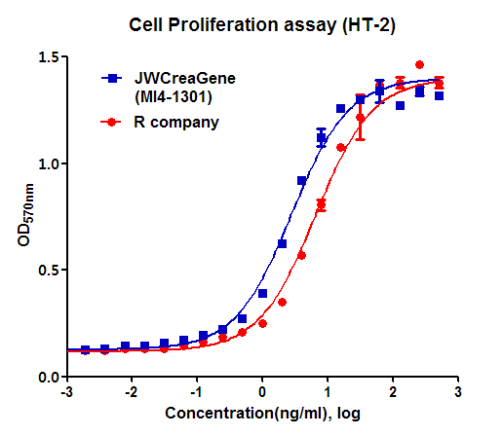
Concentration |  |  | : |  | 0.1 mg/㎖, Bradford method
Biological Activity |  |  | : |  | Determined by measuring the proliferation of murine HT-2 indicator cells.  The ED₅₀ is < 1.0 ng/ml, corresponding to a specific activity of > 1.0 × 10⁶ U/mg.
Endotoxin |  |  | : |  | Less than 0.1 EU/㎍ as determined by the LAL method
Formulation |  |  | : |  | PBS, 5% glycerol (pH 7.4) without preservative or carrier proteins.
Stability |  |  | : |  | Stable for up to 12 months at -70 ℃. Stable for a month at 4 ℃.
Sterility |  |  | : |  | Sterilized through a 0.2 ㎛ membrane filter and packaged aseptically. Culture for 2 weeks, no growth

